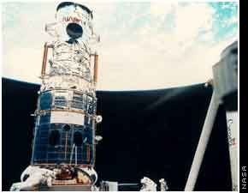**YEAR 7 SCIENCE**

**TIMELINE: HISTORY OF THE HUBBLE TELESCOPE**

**Name _____________________________**

As we have already learned the Hubble space telescope is largely responsible for much of the information we currently have about the universe. Now we are going to summarise those achievements in a timeline.

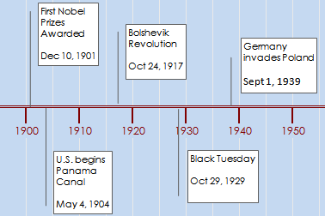

This is an example of what a timeline could look like:

Note that the scale is consistent, like you would draw on a graph.

This time line is missing other important features like a title and explanations for each of the events.

You will also add at least 1 or 2 diagrams to illustrate your point.

You are required to summarise at least 10 of Hubble's achievements throughout its history. Some dates are listed below as a starting point. It is up to you to decide which achievements you include. You must also add at least one achievement after 2001.

For each date you must say what happened and why that event is important

Suggested Dates:

* 1962
* 1977
* 1985
* 1986
* 1994
* April/May 1990
* December 1993
* November 1995
* January 1996
* February 1997
* October 1997
* November 1999
* February 2001

The following sites may help you with your research:

http://www.aerospaceguide.net/spacehistory/hubble-history.html

http://dsc.discovery.com/space/top-10/hubble-space-telescope-facts/

You may also want to include some photographs. The following site is a great gallery of images Hubble has captured throughout its history

http://hubblesite.org/hubble_discoveries/10th/photos/slide01.shtml

**Name:_______________________________**

**Hubble Telescope Timeline**

**MARKING GUIDE**

|  |  |  |  |
| --- | --- | --- | --- |
| **Section** | **Marks Available** | | **Your Score** |
| Accurate and concise information about each date listed | **20**  (1 mark for achievement 1 mark for explaining its importance) | |  |
| Correct timeline format | **\***Scale  *Points coming off at correct place *Clear | **2**  **2**  **2** |  |
| Reference list included and written in **correct** format as shown in student diary | **4** | |  |
| Appropriate diagrams | **2** | |  |
| Presentation | **2** | |  |
| **TOTAL** | **34** | |  |